User Guide

jWebSocket
Monitoring resources of computers
Orlando Miranda Gómez
Version 1.0

Version history?

1. Characteristics of the solution
The monitoring demo allows users to set up a stable and continuous monitoring of the resources of a computer in real time. You can view the status of resources from a computer or from a cell phone, just having a web browser that supports WebSocket protocol, which provides high speed and real-time work. The solution was developed with the jWebSocket framework.
This demo in addition to everything stated above provides a high level of safety, and notifies the user of the computer by email, if there is a high consumption of some of the resources thus ensuring that there is no failure or spoilage.
2. Main functionalities
- Show the state of the RAM and Swap memories.
- Show the consumption of the microprocessor in percent.
- Show the used and free space of the hard disc. This space is in the partition where the operating system is installed.
- Notify by e-mail.
The Monitoring Demo can be used in any sector of society and that is very important in protecting the components of a computer by using the web, ensuring greater availability of Web services providing by the computer. As one of the biggest advantages is that it can be viewed from anywhere in the world, just having an internet connection from both any mobile devices as well as stationary devices.
3. Problems to be solved
Problem | Contributions of the solution
Statistical monitoring of resources on the Web. This is not a “problem”, describe the problem. For instance: “In case the harddisk gets full the application may crash”. | Monitoring Demo is an application that enables continuous display of state resources in real time.  This is not a “solution”. Describe which problem is solved, for instance “If the administrator gets warned early enough by email he can add another harddrive to extend the capacity”.
The problem/solution section does not really describe potential problems and the solutions for that. Please think a bit about real problems and how they can be fixed with you tool.
4. Glossary of Terms
Real-time work: It is possible when the client receives messages from the server without prior request and end users receive updates simultaneously.
Not enough, this also applies to “full-duplex”, please give some sentences here about permanent full-duplex connection, with less latency and protocol overhead etc.
RAM: Random Access Memory. Too short! Here I need more description, at least a sentence, like “Memory in a PC-System to read and write volatile data”. Please look for definitions here.
Swap: Interchange Memory. See above!
- Model of the solution
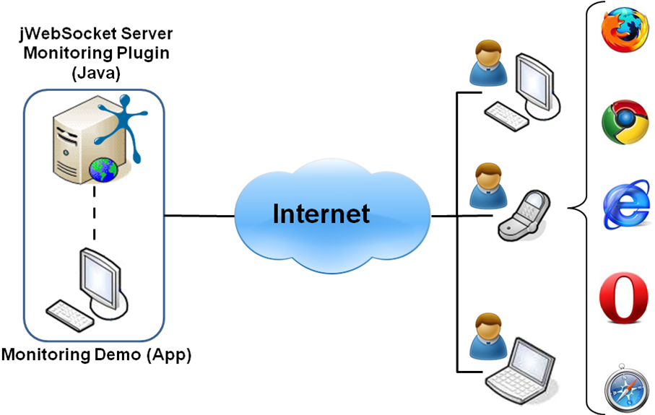
The diagram associates a user terminal at the server, running a monitoring app. Do we have that? I think not, or? If not, we should remove the desktop here, since this lets expect the user a separate desktop app. But we only have a server side plug-in, or am I wrong here?
To access the Monitoring Demo application is only required the user to use a browser that supports WebSocket protocol, not true! It also works with older browsers by utilizing the FlashBridge or the Comet Fallback. The application must authenticate against the server to obtain the information realtime status information. This way you can monitor your computer or laptop from any other station (¿) and from a cell phone. The information will be sent by the jWebSocket server installed on your computer.
7. Requirements for the use
To use Monitoring Demo must have Internet access and use any of the browsers that support the WebSocket communication protocol (see above, flash and comet?). Some of them are Google Chrome 4 +, Safari 5 +, Mozilla Firefox8 +, Opera 11+ and Internet Explorer 10 +.

8. Roles of the solution
System User: interacts with the application to observe the operation of resources. Why does the user need to know that here? What can he do? Does he have alternatives? Is that important here? If not remove.

9. System Operation
Initial and main view of the application: allows users with permissions can authenticate to the application and you can get the desired data.
How do I call this dialog? How is the “app” started?
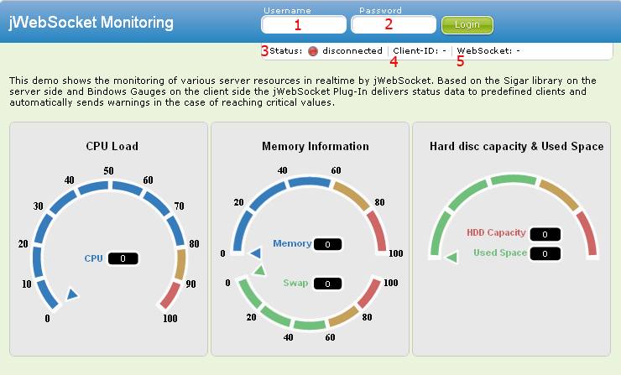
1-> Field to insert the username to authenticate against the application..
2-> Field to insert the password.
-> To access the application. Establishes the connection to the server
3-> Displays the status of the application (Authenticated / Offline).
4-> Displays the id of the websocket connection. What is that? Please explain.
5-> Displays the connection information (native/flash/comet).
Main view of the aplication: connected users can view the resources information in real time. The following screenshot shows the successfully connected application in operation.
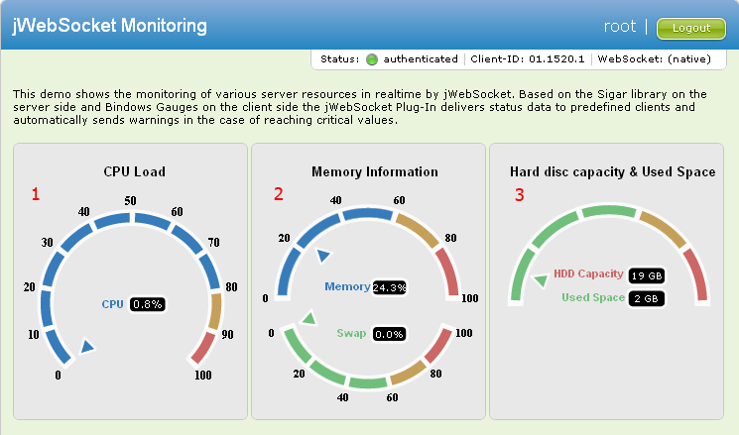
1-> Displays information about the microprocessor in percent.
2-> Displays information of the memory RAM and Swap in percent.
3-> Displays the capacity and used space of the hard disc.
-> Exits the aplication.

9. Configurations of the solution
In this application is not made settings or customizations that provides the solution.
10. Rules of the solution
R1: If the user mistypes your username or password, during Access to application, the system issues an error message and does not continue with the normal flow. Solution: The user must repeat the username and password.

In the beginning you write about Notifications per Email, I do not find anything about that here in the User Guide. Please add that accordingly.

